**Price Prediction and Demand Forecasting for a Small Fruit Shop**

**A Proposal report for the BDM capstone Project**

Submitted by

Name: Shaonkoli Saha

Roll number: 21f1001196



IITM Online BS Degree Program,

Indian Institute of Technology, Madras, Chennai

Tamil Nadu, India, 600036

**Contents**

1 Executive Summary and Title 3

2 Organization Background 3

3 Problem Statement 3

3.1 Problem statement 1: Lots of fruits are getting soured daily 3

3.2 Problem statement 2: Number of buyers are lesser than other fruit shop 3

4 Background of the Problem 3

5 Problem Solving Approach 4

6 Expected Timeline 4

7 Expected Outcome 5

**Declaration Statement**

I am working on a Project titled “Price Prediction and Demand Forecasting for a small Fruit Shop”. I extend my appreciation to **Mr. Narayan Das**, for providing the necessary resources that enabled me to conduct my project.

I hereby assert that the data presented and assessed in this project report is genuine and precise to the utmost extent of my knowledge and capabilities. The data has been gathered from primary sources and carefully analyzed to assure its reliability.

Additionally, I affirm that all procedures employed for the purpose of data collection and analysis have been duly explained in this report. The outcomes and inferences derived from the data are an accurate depiction of the findings acquired through analytical procedures.

I am dedicated to adhering to the principles of academic honesty and integrity, and I am receptive to any additional examination or validation of the data contained in this project report.

I understand that the execution of this project is intended for individual completion and is not to be undertaken collectively. I thus affirm that I am not engaged in any form of collaboration with other individuals, and that all the work undertaken has been solely conducted by me. In the event that plagiarism is detected in the report at any stage of the project's completion, I am fully aware and prepared to accept disciplinary measures imposed by the relevant authority.

I understand that all recommendations made in this project report are within the context of the academic project taken up towards course fulfillment in the BS Degree Program offered by IIT Madras. The institution does not endorse any of the claims or comments.



Signature of Candidate: (**Digital Signature**)

Name: Shaonkoli Saha

Date: 05-03-2024

# Executive Summary and Title

The project focuses on a small fruit shop located at Kalindi Housing Estate, Kolkata. The business is B2C and deals with different types of fruit.

The major business issues that the owner is facing are related to a very nominal profit due to wastage of inventory on daily basis. This problem pushes him so sell the product on higher price to make profit, which leads to less buyers to his shop.

The issues will be addressed by analyzing the data and will provide effective solution so that it can help the business owner to reduce the money blockage in terms of inventory. This will help the business to increase the profitability of the organization.

# Organization Background

The shop owner with whom I am working with is Mr. Narayan Das. His fruit shop is located at Kalindi Housing Estate market. He started his business on 15th April 2001. At that time market used to settle by the road. He used to sit near crossing from where his shop had very good visibility. Now, since 23rd Oct 2020, the entire market is shifted in a small market area.

# Problem Statement

## **Problem statement 1: Lots of fruits are getting soured daily.**

The business owner is facing wastage of inventory on daily basis, which makes him to sell the product on higher price to make the profit.

## **Problem statement 2: Number of buyers are lesser than other fruit shop.**

As per the problem statement 1, he is selling his product on higher price of the market rate. So, customers are less attracted to his shop.

# Background of the Problem

**The major cause of the problem:**

The buyers in his shop have been decreased after the location change. Earlier, he used to sit at the crossing and his shop was visible for a wide range of customers. But now his shop location is barely visible from the entrance of the market. Two more fruit shops are there before his shop. So, customer attraction is less now.

Mr. Das is still having the same amount of inventory as earlier. To make the profit, he chooses to sell the product with high margin which makes the customer not so attracted.

# Problem Solving Approach

1. **Data Collection** – In this process, I will talk to the business owner and will take the ledger book of the year 2023(Jan to Dec). I will store this information in excel sheet. As per the data, the business owner buys inventory on weekly basis. Also, market research is required from other fruit business owners.
2. **Data Cleaning** – Two types of data are there. Weekly buying product for inventory and Daily sell. Data cleaning is required to understand actual sell and wastage of product. I will use excel for data cleaning.
3. **Finding Insights of the data** – Need to understand why there is wastage of product. From the market research data, need to understand consumer requirement. I will use pivot table in excel to find the insights.
4. **Finding Solutions** – Will find solutions to mitigate the ‘wastage of product’ problem. Based on the insights of the data, we can provide solution options for Mr. Das to work on his business.

# Expected Timeline

Talk to Business Owner

Market Research

Collecting Data

Finding Solutions

Finding Insights

Data Cleaning

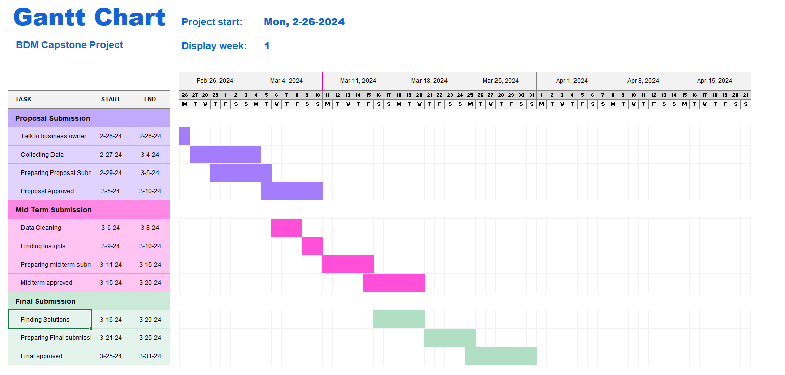*.*

# Expected Outcome

The expected outcome is to provide a solution to Mr. Das so that he can make profit on regular basis. For that he needs to work on his business strategy. He also needs to plan his inventory in smarter way. This project will provide him the options to work on it.